Launch kit posters

How can I edit this poster?

- To edit the poster, please select File -> Make a copy
Note: The document can be edited only on google docs. If you wish to make any further changes do contact support@freshservice.com
- If you wish to replace the existing QR Code, select the QR code, right-click and select “Replace image”. Also, ensure that the QR code image size is within 100x100 pixels or 90x90 pixels
- Use only “Roboto” font while editing the poster content
- To export it as a pdf, go to File -> Download -> PDF Document (.pdf)

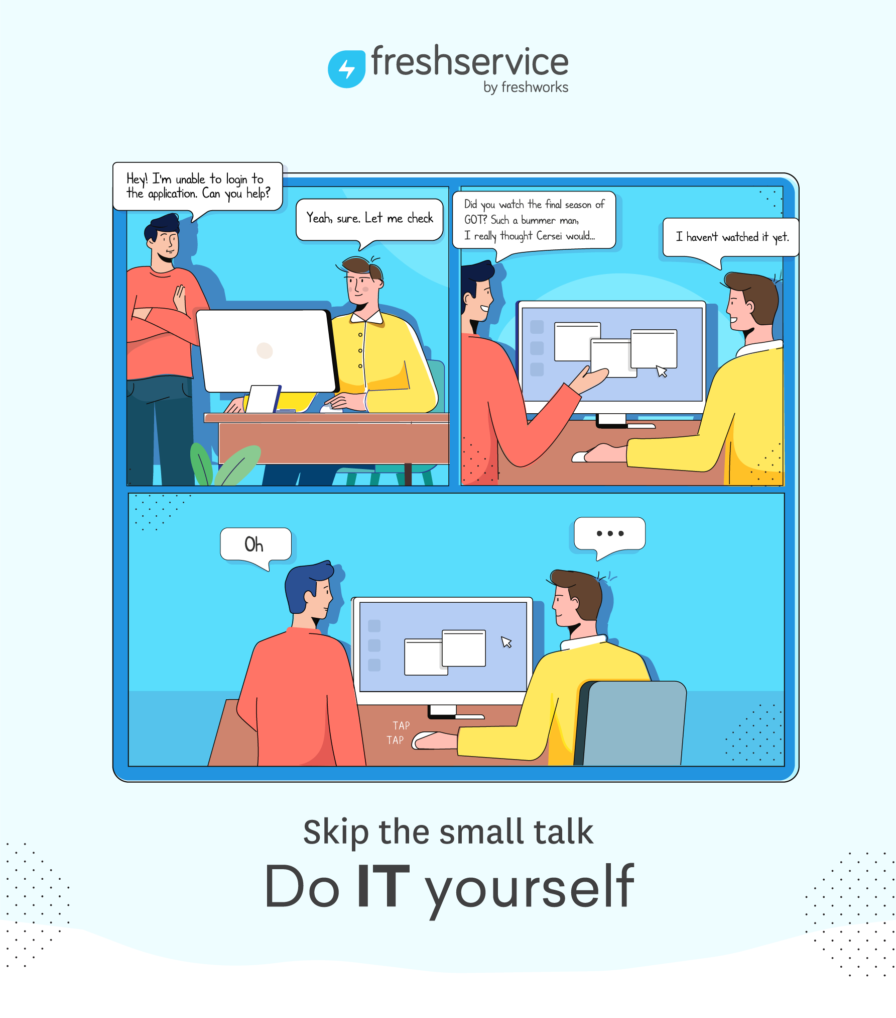
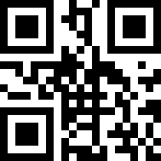
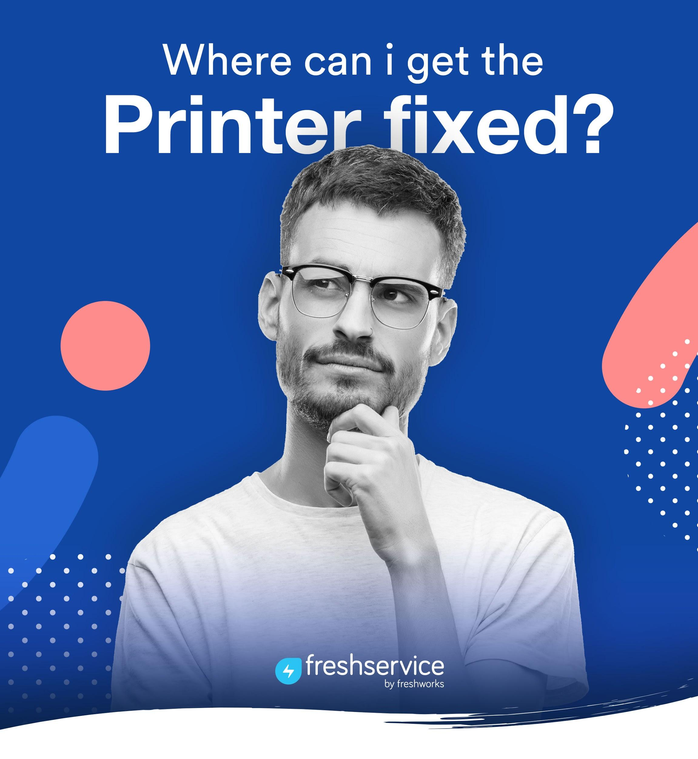
Visit our Portal Today!
https://medhealth.freshservice.com/support/home
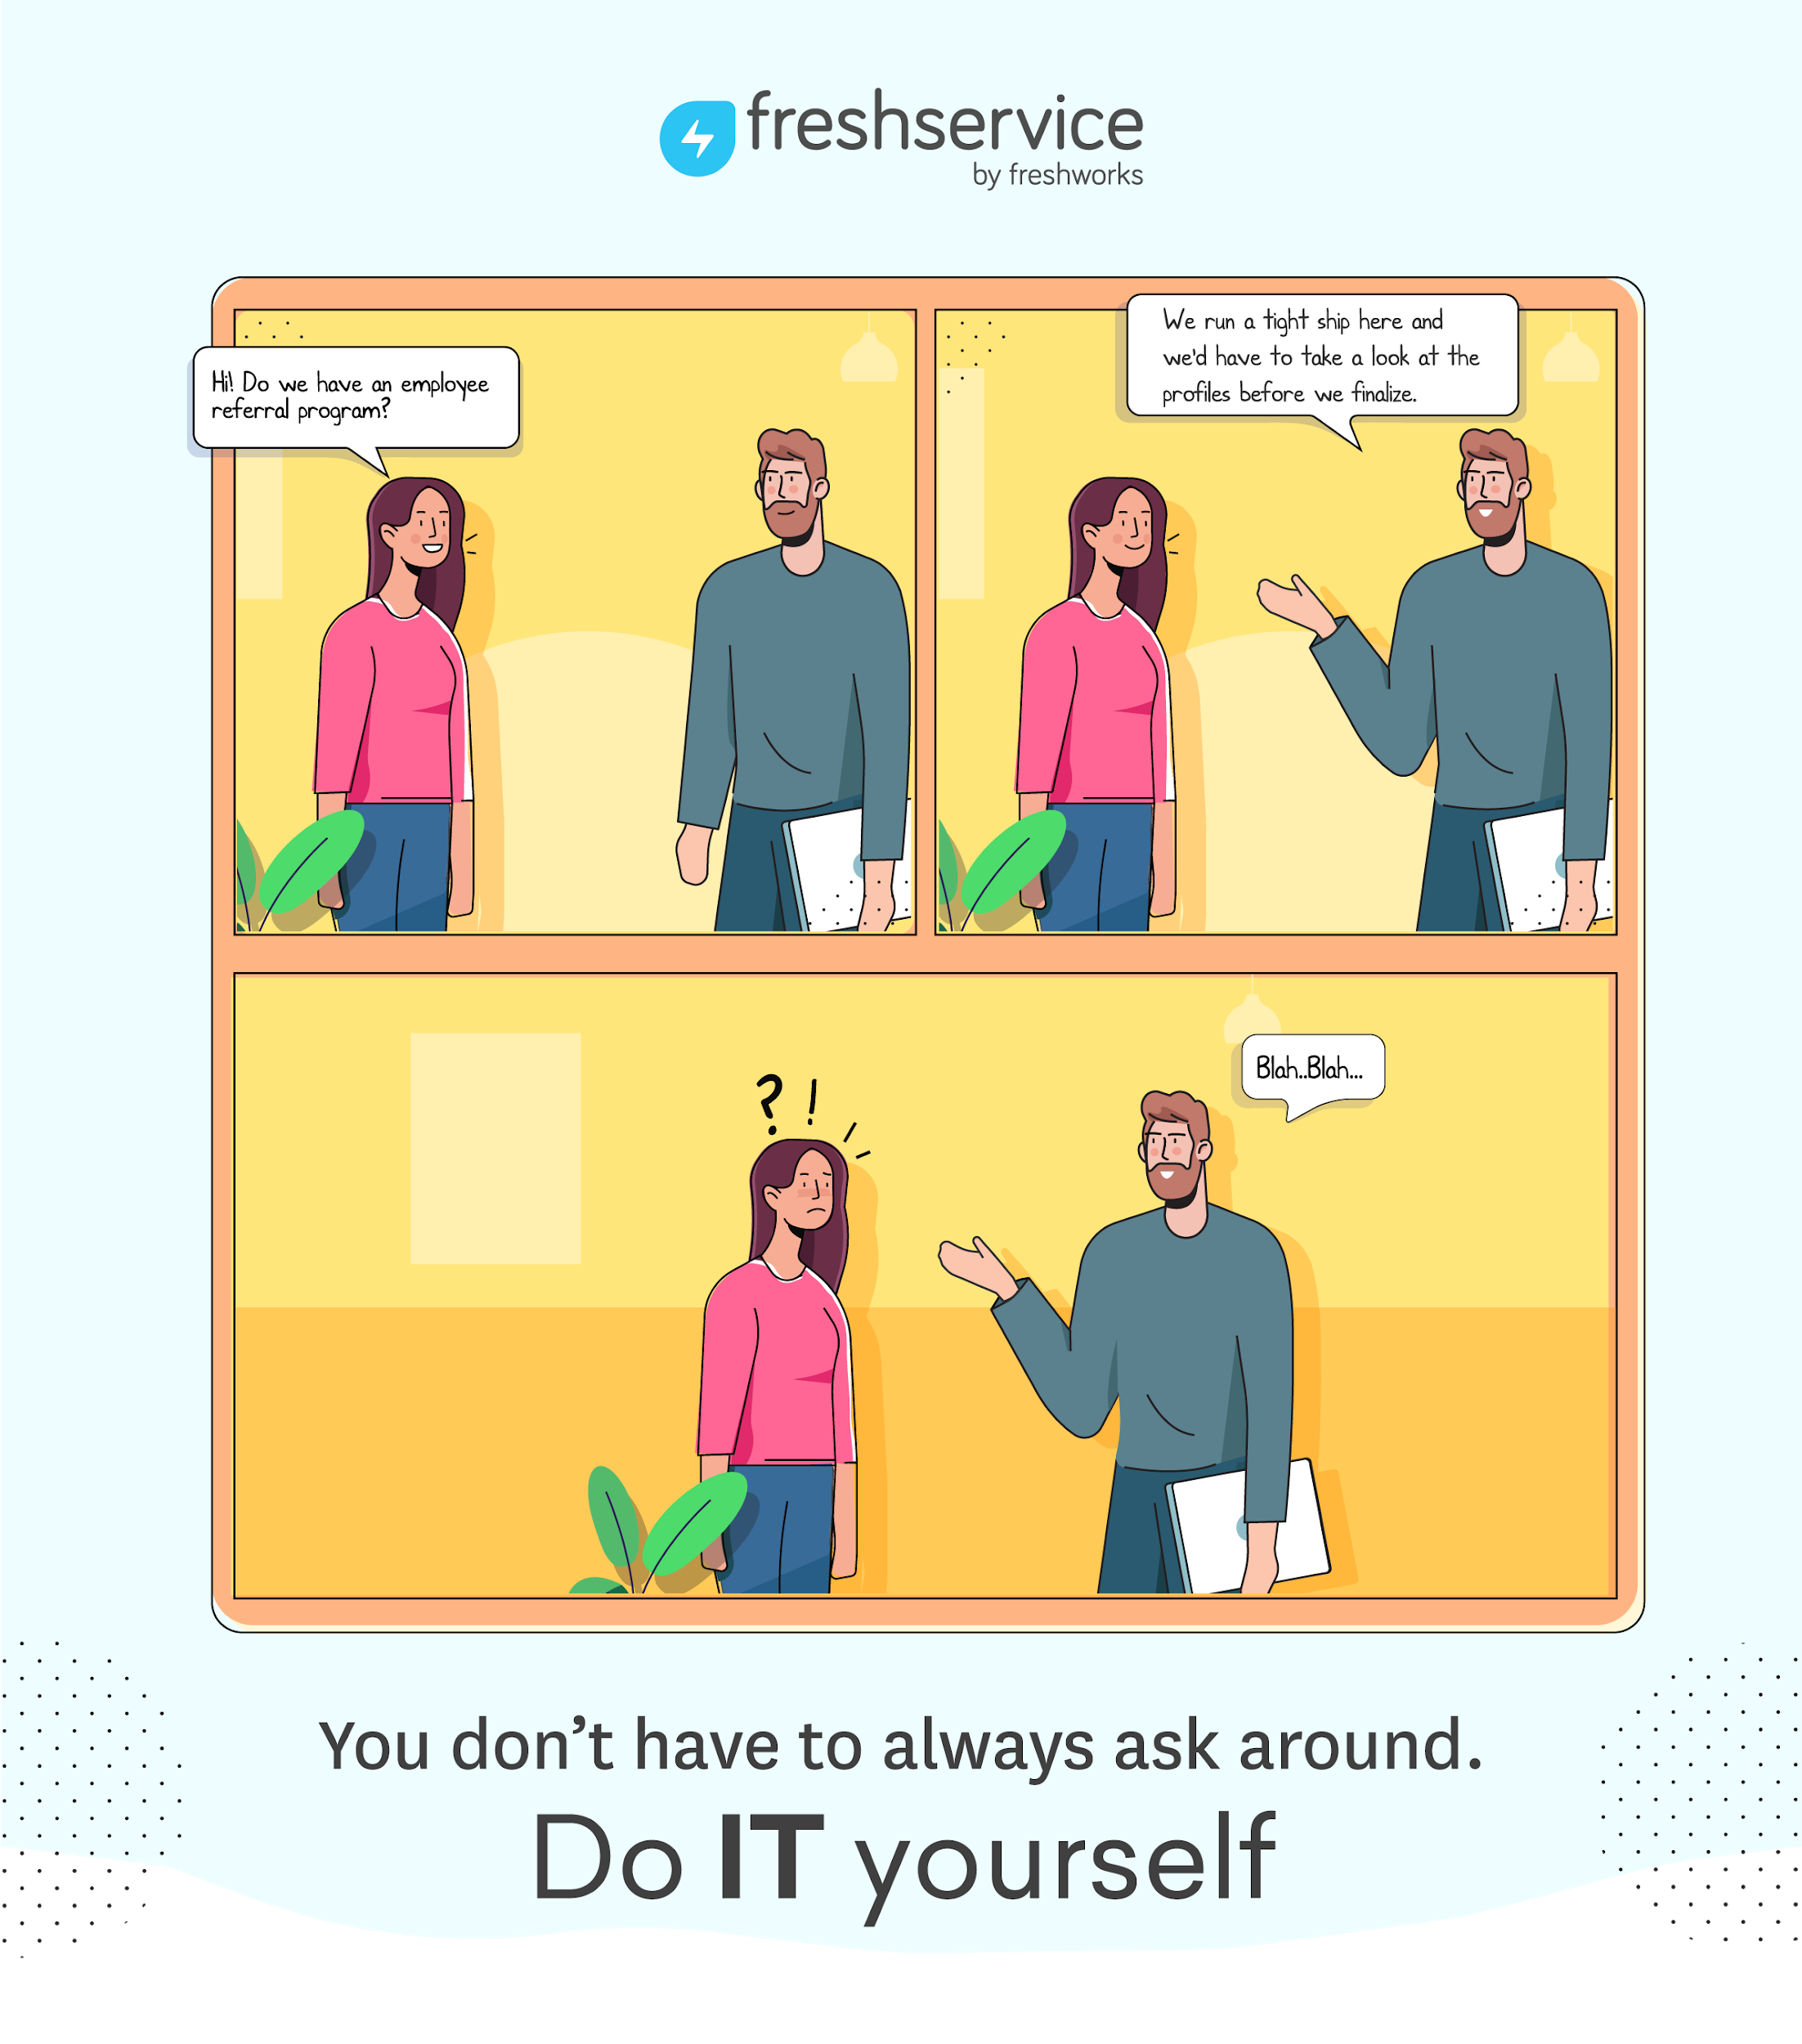

Visit our Portal Today!
https://medhealth.freshservice.com/support/home
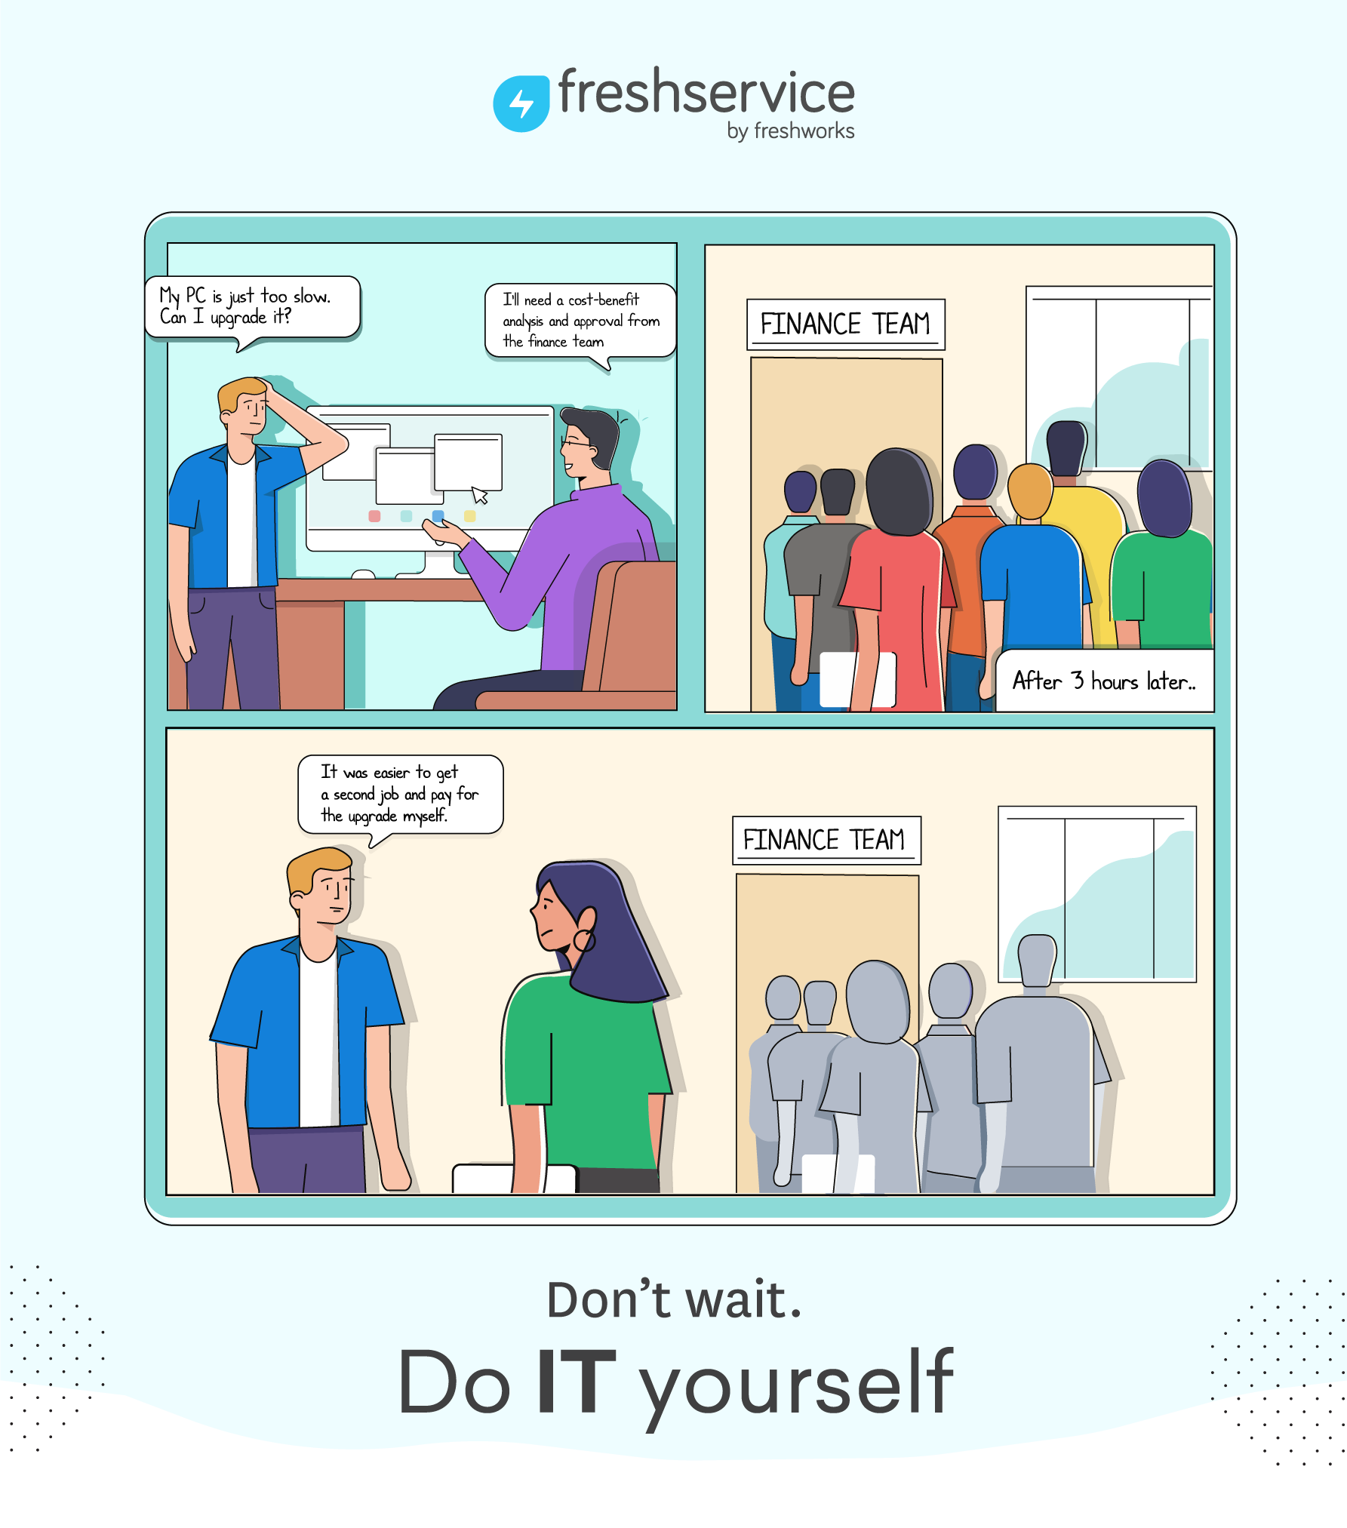
Visit our Portal Today!
https://medhealth.freshservice.com/support/home
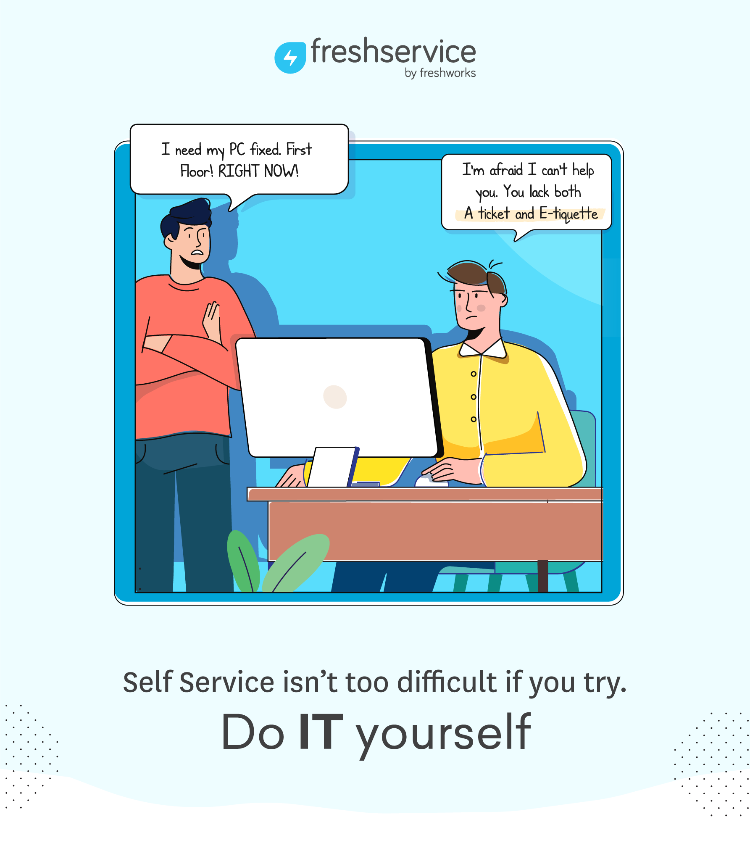
Visit our Portal Today!
https://medhealth.freshservice.com/support/home

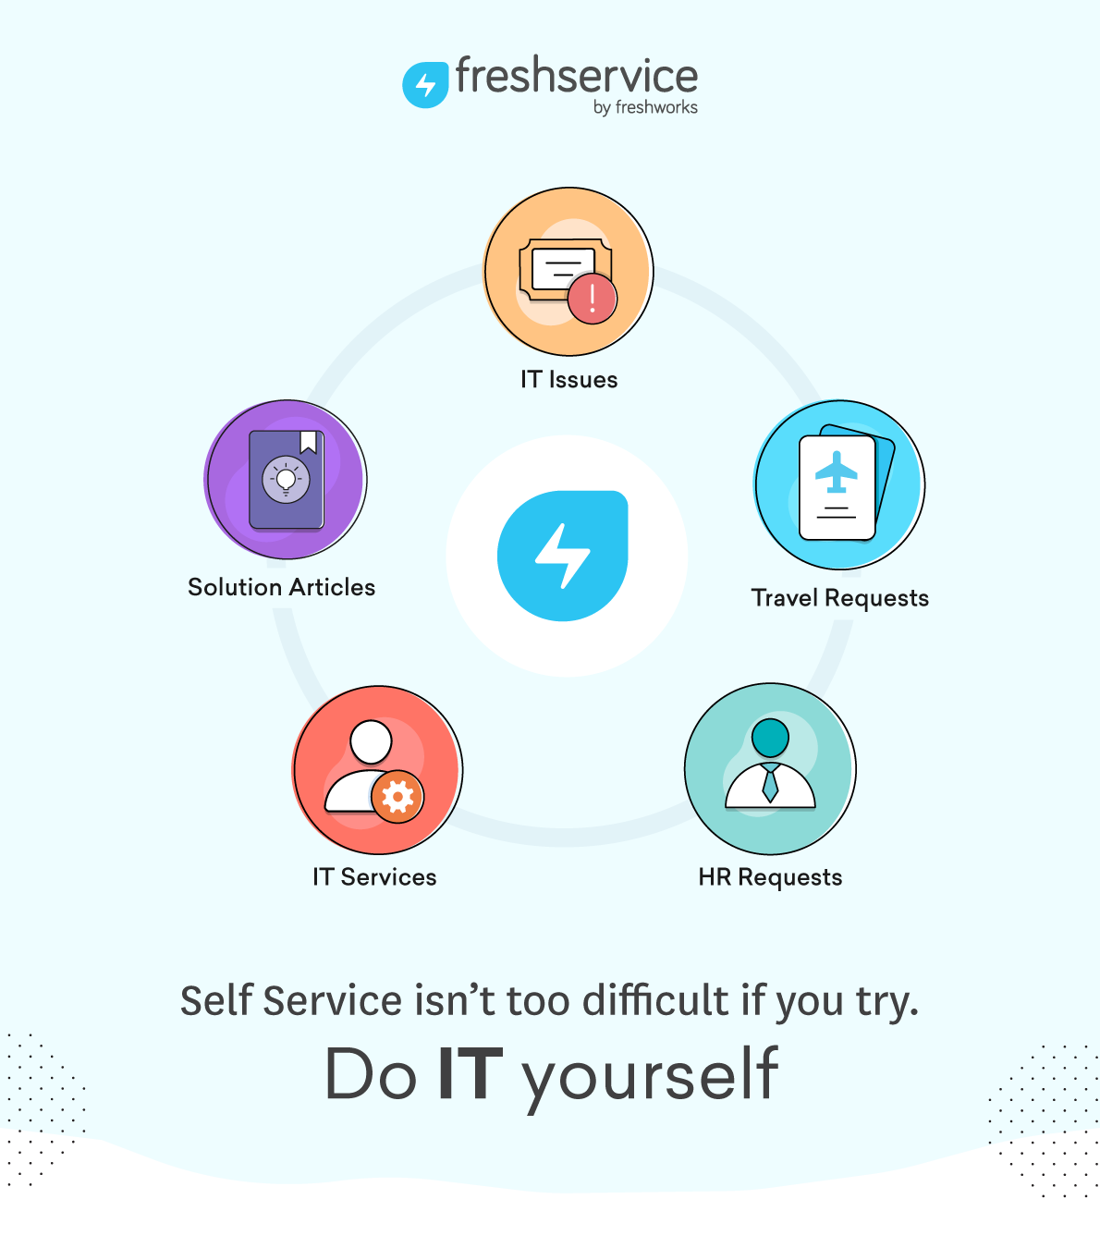

Visit our Portal Today!
https://medhealth.freshservice.com/support/home
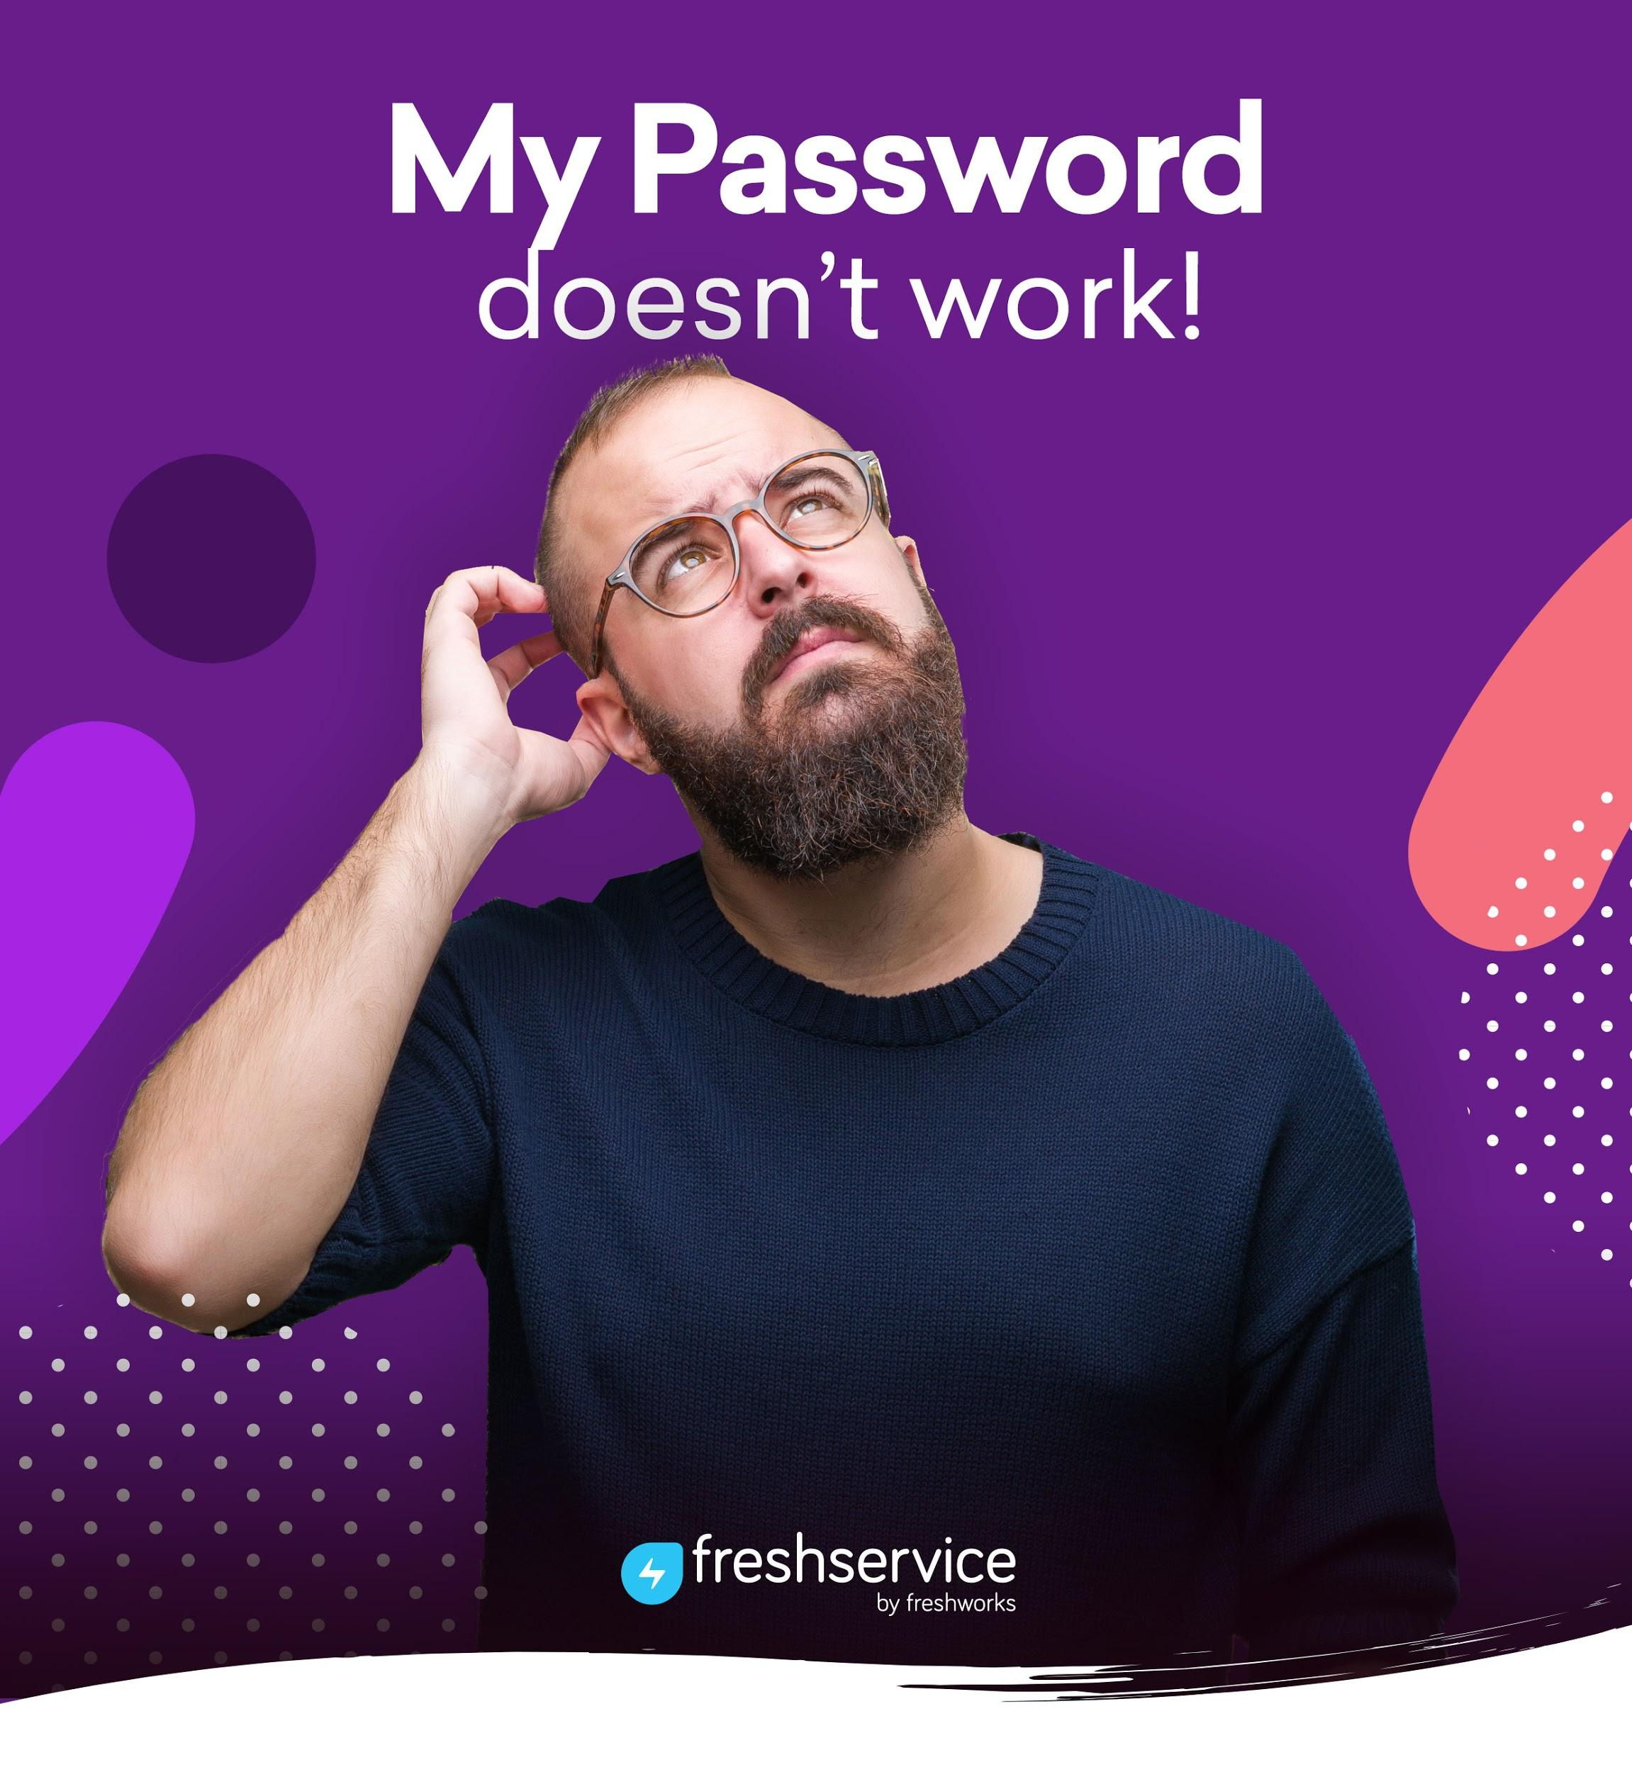
Visit our Portal Today!
https://medhealth.freshservice.com/support/home

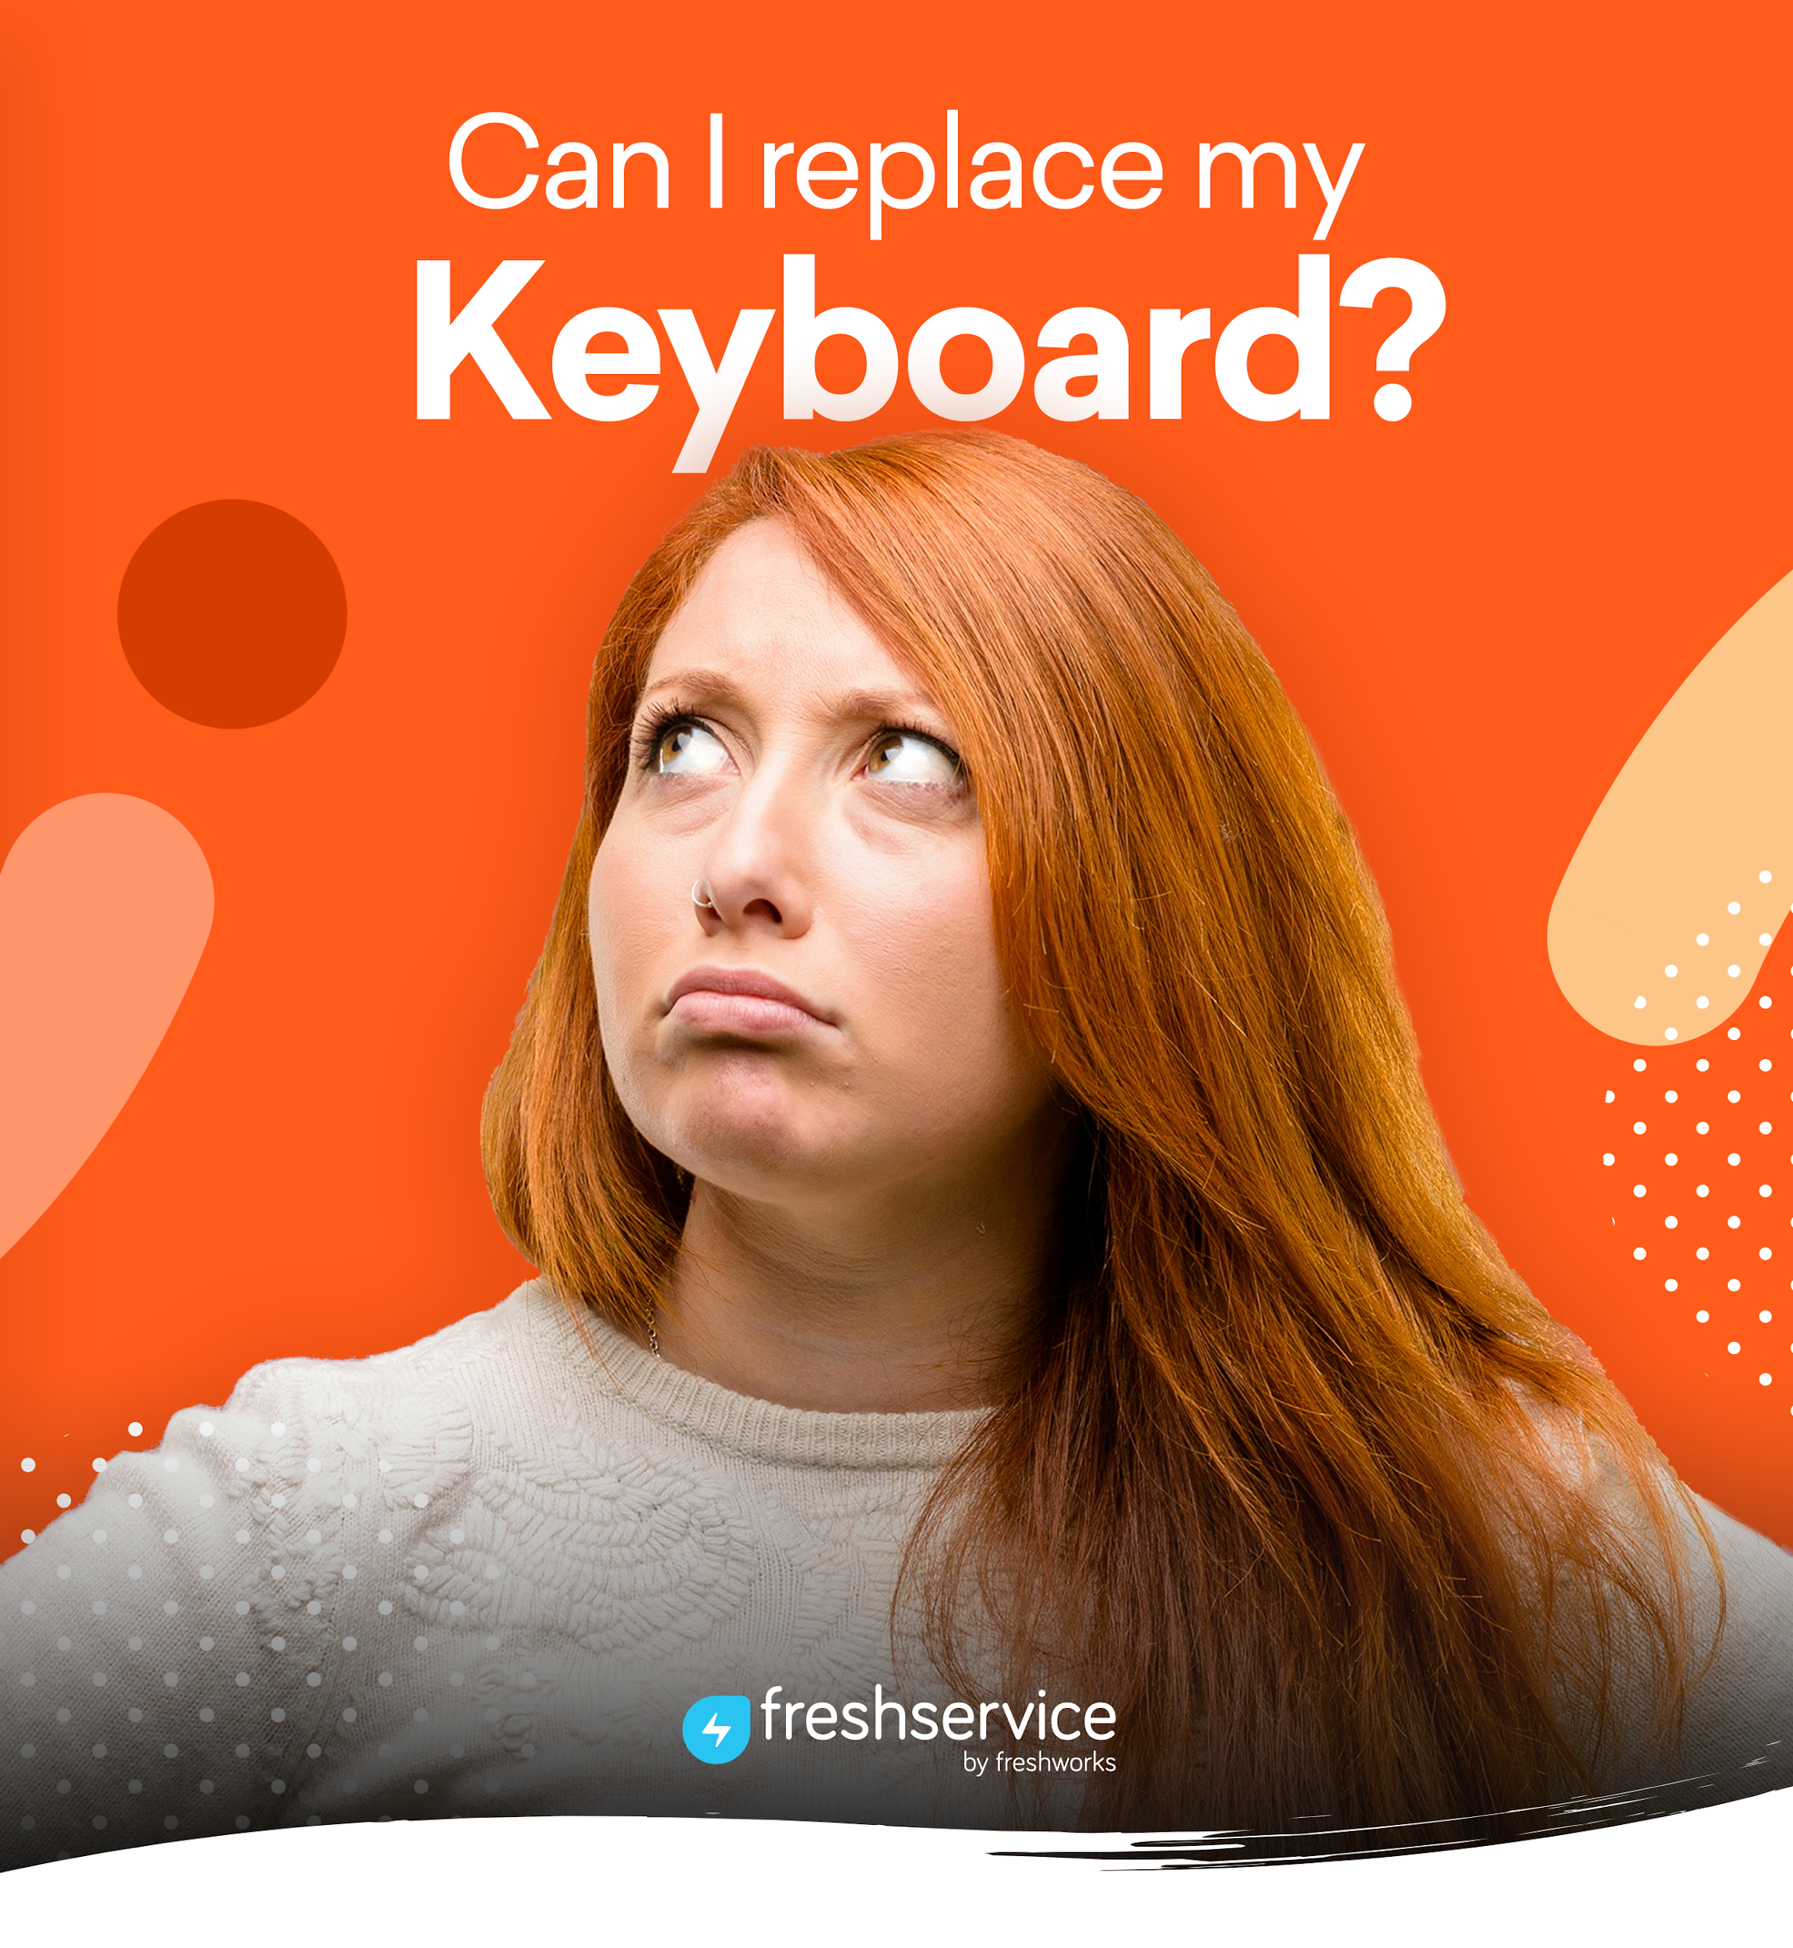
Visit our Portal Today!
https://medhealth.freshservice.com/support/home

Visit our Portal Today!
https://medhealth.freshservice.com/support/home
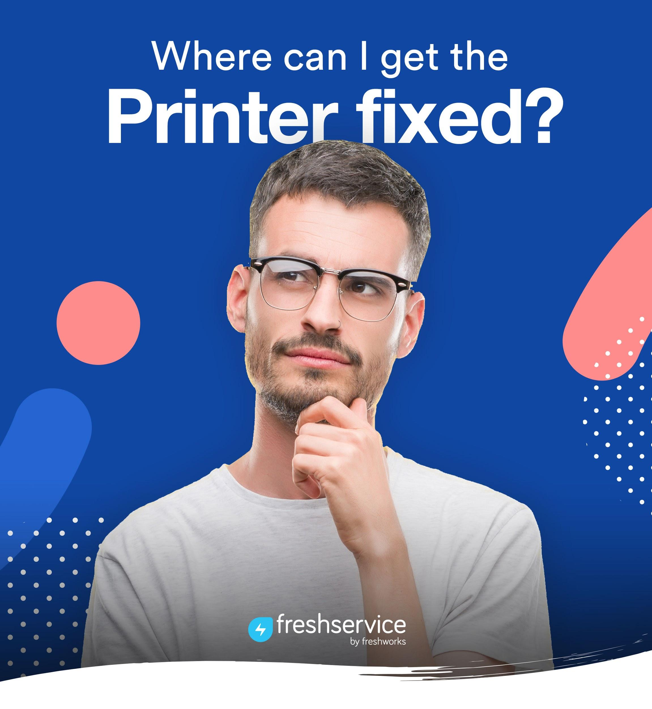
Visit our Portal Today!
https://medhealth.freshservice.com/support/home

